Instructor annotations are in red.

Education Constitution Preamble
We the students, in order to form a learning environment that addresses the needs of all students of all abilities, set forth this document in which we provide for the common defence of education, promote the welfare of all students, establish consequences, and ensure classroom tranquility, do ordain and establish these expectations. ​(This would not require an amendment.)

Education Constitution
Article I
Quorum
- There must be at least 25% of students present to hold class. ​Students may wish to revise this depending on the average number of students in a class or even the type of class this is used in (middle school, high school, Advanced Placement, International Baccalaureate, general studies, etc.).
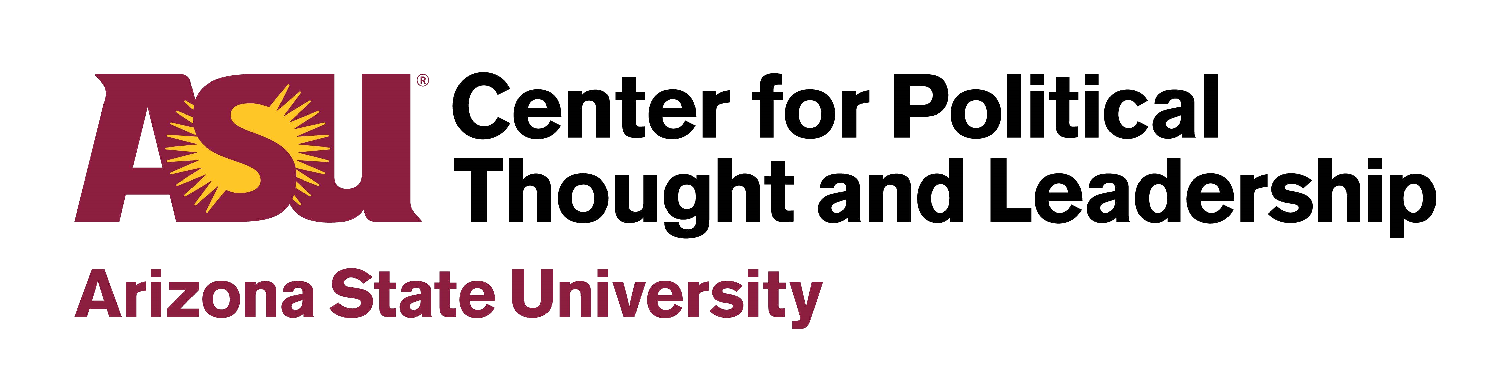
Article II
Procedures
- All students will raise their hands to speak. The teacher will call on students in the order in which hands were raised. ​This might be open to change depending on the school or the size of the classes.
- One person may speak at a time.
- All students have the same rights:
  - the right to be heard
○ the right to question ​What does it mean “to question”? Are there guidelines on how to question?
○ the right to oppose ​What does it mean “to oppose”? Should there be guidelines on how to oppose?
○ For questioning and opposing, students might want to think in terms of questioning/opposing in a way that does not violate others’ rights.
- All students have the same responsibilities:
  - the responsibility to follow procedures as listed in the Education Constitution
○ the responsibility to respect others ​What does it mean to respect? Are there different levels of respect?
○ the responsibility to come to class prepared ​Students may want to expand on this. Are there cases where it is okay to be unprepared (e.g., absent from school)?
○ Are there other responsibilities that are not covered in this constitution? What else is a general expectation of students?

Article III
Integrity
- All students will strive to maintain their integrity. To that end, they will:
  - always do their own work
○ use appropriate language
○ complete their work on time and neatly
○ Make sure that students know what “integrity” means.
○ What are other ways that they can be honest and do the right thing?
○ This would be a good section to add an amendment about bullying, hate speech, appropriate political speech, academic honesty, behavior on social media, and other related problems that students currently face.
Article IV
Property
- Each student will have his or her own desk.
  - Students are responsible for keeping their desks clear and refraining from drawing on or breaking them.
- Students are charged with helping maintain a positive learning environment by keeping the classroom neat.
- Students may want to add amendments about recycling, reducing waste, graffiti, litter, or other issues relating to school property.
Article V
Sanctions
- Students are responsible for following policies set forth by the School
Administration relating to absences, tardiness, disrespect, and other behavioral issues.
- Failure to follow these policies can result in loss of privileges.
- Depending on the type of class this is used in, rather than adding specific sanctions, students may want to introduce an amendment that talks about how certain problems (e.g., taking someone’s lunch, going into someone’s locker or desk without permission, not participating in a group activity) will be handled within the class (e.g., a jury of one’s peers).
- Remind them that, like the U.S. Constitution, they cannot encourage “cruel and unusual punishment.”

